DOES LITTERATURE REFLECT THE IMPORTANCE OF PLAY IN CHILDREN DEVELOPEMENT ?

- INTRODUCTION
  - Problem

Playing is often associated with youth, amusement and creativity. However, "play is essential to development because it contributes to the cognitive, physical, social, and emotional well-being of children and youth." (Kenneth R. Ginsburg, MD, MSEd, 2007). Moreover, it is often said that artist - and writers amongst them - are children at heart. But are they really ?

Hence we wonder if there is a difference in the use of the concept of "play" between children's literature and literature aimed at an adult audience.
If it were the case, we should observe that the "jeu" family words are less used in adult litterature than in youth litterature.

It would be interesting to know whether there is or not an imbalance in the use of ‘jeu’ since it may reflect a difference in the importance of play between youth and adulthood.

  - Data

We will be using txt files cointaining the raw content of serveral books. We've selected a small corpus of texts since they were manually collected. We chose two book series (in order to get volume as well as cohesiveness), both belonging to the fantasy genre and both written between 2000 and 2010 (in order to reduce bias on those features). For the children's litterature, we picked the Book of Stars trilogy, written by Erik L'Homme. Then, we used Haruki Murakami's trilogy 1Q84 for the adult or general litterature.

We will also be using the trained pipeline for French "fr_core_news_sm" from SpaCy.
We then created a dataset with every sentences of these books separated. We were able, using "fr_core_news_sm", to extract the lemmas of each word, hence introducing our final dataset (N = 654756 rows × 12 columns). After manipulating the data, we created and used our original columns to test our prediction.

- LIBRARY AND DATA IMPORT

We used python librairies for all parts of the data analysis. We also used the google.colab library since the project was led on this platform. If opened in another environment, this library would be useless and the files upload for the data import would be set aside.
Because we worked on google colab, the code required adding a line (A) before loading the SpaCy natural language processing pipelines :
!python -m spacy download fr_core_news_sm #(A)
nlp_fr = spacy.load("fr_core_news_sm")
We then read the text files and opened them with a function built to separate sentences, which provided a first dataset with one sentence per row.
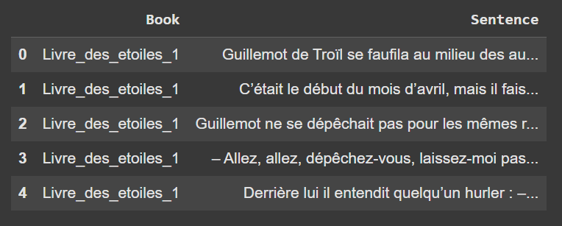

- DATA MANIPULATION AND DESCRIPTION

Then we used the previously loaded nlp to get the lemma and tag of each token. 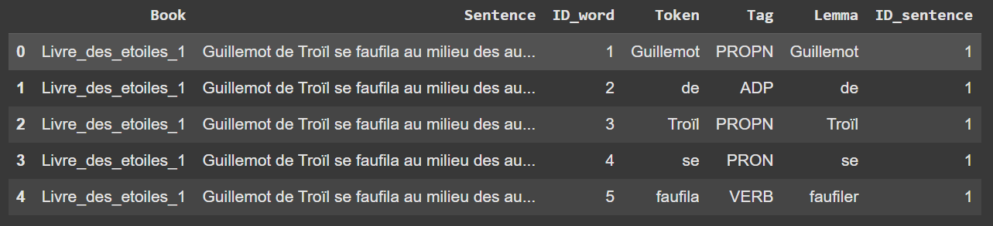
Eventually, we created our final dataset by removing a few useless rows as well as adding 5 columns about ‘jeu’ (‘play’) words and about the type of littérature of the data, that we would use later in our analysis.
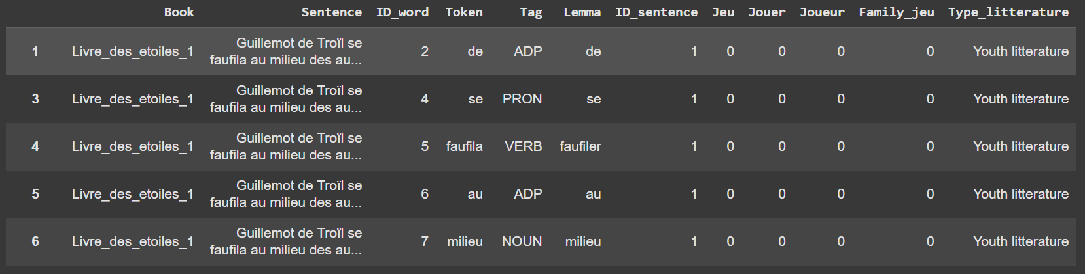

We then plotted the variables that we would use for the rest of the analysis. We can see that despite having a corpus composed of the same number of books for both types of littérature, there is more than twice the amount of words for Adult litterature as there are for Youth lliterature (see Fig. 1). This can be explained by the fact that children books are usually shorter.
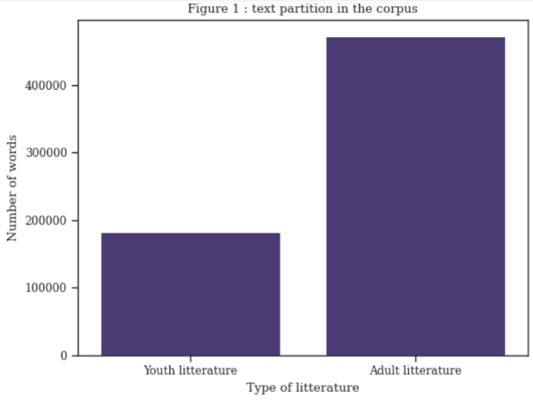

We also plotted the number of apparition of each lemma studied (‘jeu’, ‘jouer’, ‘joueur’ and the sum of those 3) in order to see what the repartition of these words were. We can see that the proportion of words formed by those lemmas compared to all other words is extremely unequal. It is not surprising since we are studying large pieces of litterature where playing is not the main theme of the books.
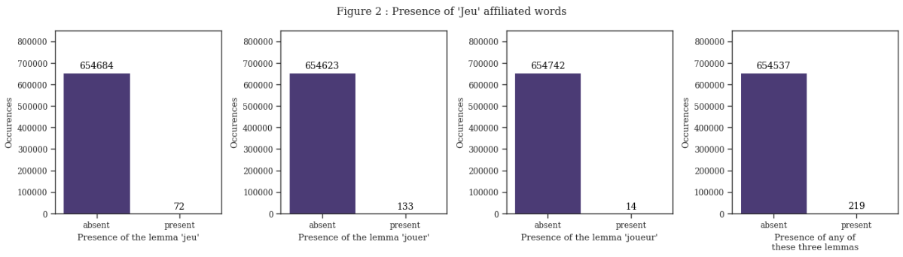

- ANALYSIS AND DATA MODELLING

We performed a χ² test to test our prediction, using a contingency table.
We got those results :
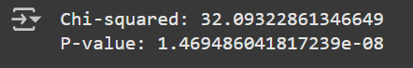

We then plotted both expected and observed heatmaps in order to get a visual idea of the variables of the text.
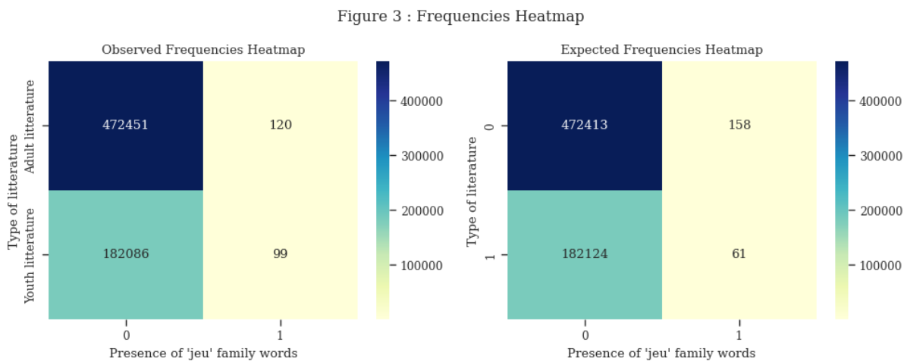

- RESULTS AND INTERPRETATION

We tested if there were significantly more occurrences of the ‘jeu’ family words in youth literature than in adult literature and we found that it was indeed significant (*p* < 0.001). Hence my prediction was right and youth literature significantly favours the family words of ‘jeu’ compared to adult literature.

